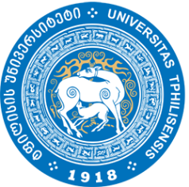
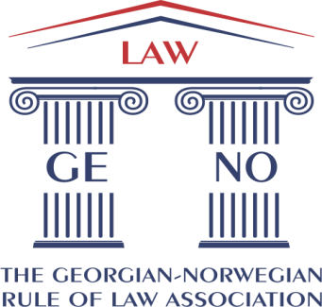

The 3rd Annual Rule of Law Conference

Georgian-Norwegian Perspectives on International Criminal Law and its Sources
Mapping the Challenges to Theory and Practice in the Digital Age

Date:
Friday, 20 May 2016

Venue:
Tbilisi State University
I Block, Auditorium 107
1 Chavchavdze Ave, 0179 Tbilisi, Georgia

Agenda:

9:00-9:20 Opening remarks

Mr. Giorgi Giorgadze
President, The Georgian-Norwegian Rule of Law Association

Mr. Bård Ivar Svendsen
Norway’s Ambassador to Azerbaijan and Georgia

Mr. Walter Wangberg
Head of Mission, NORLAG - The Norwegian Rule of Law Advisers Mission to Georgia (2012-2013)

Prof. Moris Shalikashvili
Deputy Dean and Associate Professor of Criminal Law, Faculty of Law, Tbilisi State University

9:20-11:00 Introductory Matters on (Traditional) International Criminal Law

Ms. Sofie A.E. Hogestol, The Jurisdiction of the International Criminal Court: Current Jurisdictional Questions

Prof. Merab Turava, Judge of Constitutional Court, The Legal Framework of Cooperation between Georgia and the International Criminal Court

Mr. Giorgi Dgebuadze, Assistant of Prof, Criminal Law Faculty at the Tbilisi State University
Criminal Responsibility of Superiors in International Criminal Law

Mr. Givi Bagdavadze, Chief Prosecutor’s Office Admission of Open Sources as Evidence in War Crimes Trials: Opportunities and Challenges

Followed by the Q&A

11:00-11:15 Coffee break

11:15-13:00 Modern Challenges to (International Criminal) Law Research

Dr. Gert Johan Kjelby, What Makes a Legal Article Good?

Dr. Giorgi Russiashvili, Writing the Scientific Paper

Mr. Bard Sverre Tuseth, Modern Challenges for Legal research: Focus on Technological Development

Dr. Emilie Hunter, Sources and Resources for International Criminal Law Research

Followed by the Q&A

13:00-14:00 Lunch break

14:00-15:30 National Prosecution of International Crimes

Dr. Anna Dolidze, Challenges of Conducting a Transnational Investigation

Dr. Thomas Froberg, Prosecution of International Crimes in Norway

Mr. Teimuraz Antelava, Georgia and the International Criminal Court: a Complex Juncture of Law and Politics

Followed by the Q&A

15:30-15:45 Coffee break

15:45-16:45 The Role of Technology in Prosecution of International Crimes

Mr. Bard Sverre Tuseth, International Criminal Law – Digital and Authoritative Sources

Mr. Ilia Utmelidze, Can the Enhanced Work Methods and Technological Tools Assist National Prosecution of Core International Crimes? The Case of Bosnia and Herzegovina and Beyond

Followed by the Q&A

16:45-17:00 Presentation of the winner of The Rule of Law annual law students’ writing competition

[End of the academic part of the conference]

From 21:00 Reception and the conference dinner hosted by the Georgian-Norwegian Rule of Law Association
Venue: Funicular Restaurant Tbilisi

